Use-Case Realization Report (Analysis)
View Sales Order

Issue <1.0>
Revision History
Date | Issue | Description | Author
<29/Jul/11> | <1.0> | Initial Document | Koh Ming Jin

Table of Contents
1. Brief Description 4
2. Flow of Events 4
2.1 Standard Flow 4
2.2 Exception 4
3. Interaction Diagrams 4
3.1 Collaboration Diagram for View Sales Order 4
4. Participating Objects 4
4.1 Role Main Page 4
4.2 Sales Order Controller 4
4.3 Sales Order Detail 4
5. Class Diagrams 5
5.1 Domain Class Diagram: View Sales Order 5
6. Derived Requirements 5

Use-Case Realization Report
View Sales Order

Brief Description
This use case enables a Sales Staff to view a Sales Order record.

Flow of Events
The standard flow of events for this use case and any exceptions are described in the following subsections. See section 3.1 for an overview of the participating Actors and Domain Objects.

Standard Flow
The flow of events is described as follows:

- The use case starts when the authenticated Sales Staff selects the View Sales Order option of the system.
- The View Sales Order Page, which includes all the Sales Order details, will be displayed.
- The use case terminates.

Exception
- NIL

Interaction Diagrams

Collaboration Diagram for View Sales Order
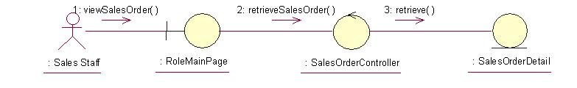

Participating Objects

Role Main Page
This object renders the contents to allow the authorized Sales staff actor to perform his or her jobs.

Sales Order Controller
This object acts as the middleman between related Sales Order Pages and the Sales Order and Sales Order Detail objects. It will translate interactions with the view into actions to be performed by the Sales Order or Sales Order Detail objects.

Sales Order Detail
This object stores the details concerning the Sales Order Detail of the COMS.

Class Diagrams

Domain Class Diagram: View Sales Order
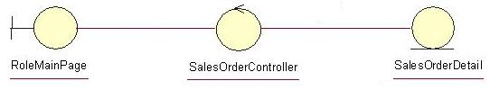

Derived Requirements
The Sales Staff PC keyboard and mouse will be used to retrieve Sales Order details (if any) and view all the system responses.

